Bay Journal

Appeals court upholds Chesapeake Bay cleanup plan
Farm Bureau challenge turned away firmly
- By Karl Blankenship on July 06, 2015

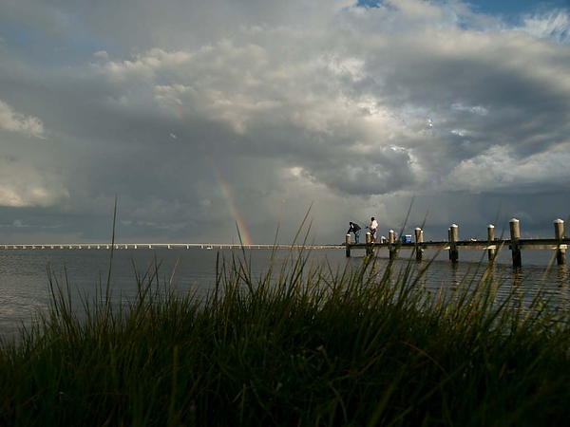
The TMDL is aimed at restoring water quality needed for fish, shellfish, waterfowl and underwater grasses. (Dave Harp)
The 3rd U.S. Circuit Court of Appeal Monday upheld the EPA’s authority to require an expansive Chesapeake Bay cleanup plan, firmly rebuffing challenges by farm groups and a coalition of states.
The court in its 60-page ruling stated that the EPA’s Chesapeake Bay Total Maximum Daily Load, or TMDL, “is reasonable and reflects a legitimate policy choice,” while calling various arguments by the American Farm Bureau Federation and its allies “illogical,” “unpersuasive,” “defies common sense” and, in one instance, “long on swagger but short on specificity.”
It was the second court defeat for the Farm Bureau, which challenged the TMDL in federal District Court only weeks after it was issued in December 2010. That challenge was rejected in 2013 by U.S. District Judge Sylvia Rambo. The Farm Bureau then appealed to the 3rd Circuit in Philadelphia.
During oral arguments last October, the three-judge panel hearing the appeal seemed skeptical of the Farm Bureau’s claims, and that skepticism was repeatedly voiced in the ruling, which noted that the EPA had worked closely with the states to develop a plan to restore Chesapeake Bay water quality after earlier cleanup efforts had repeatedly failed.
“Congress made a judgment in the Clean Water Act that the states and the EPA could, working together, best allocate the benefits and burdens of lowering pollution,” Judge Thomas Ambro wrote in the unanimous ruling, “The Chesapeake Bay TMDL will require sacrifice by many, but that is a consequence of the tremendous effort it will take to restore health to the Bay…a goal our elected representatives have repeatedly endorsed.”
The Bay TMDL established the maximum amount of nitrogen, phosphorus and sediment that the Bay could receive and still attain water quality needed to support various healthy aquatic life, from burrowing worms to underwater grass beds to fish and crabs.
The TMDL then allocated those loads to various regions and pollution sources — regulated point source discharges and unregulated nonpoint sources of runoff — and required that states write plans showing how they could reasonably achieve those pollution reductions by 2025 (with 60 percent of the needed actions to be taken by the end of 2017).
The Farm Bureau and its allies contended that the EPA had overstepped its Clean Water Act authority in making such specific requirements. It argued that a “load” was only a single number for a waterbody, and could not be subdivided among sources and regions, charging that by doing so, the agency was in effect regulating land uses. It further said the EPA had no authority to set deadlines and require states to provide detailed cleanup plans.
The court rejected all of those arguments. Determining the amount of pollution reductions needed to achieve a clean Bay requires a detailed analysis, the court said, it “would be strange to require the EPA to take into account the specific considerations but at the same time command the agency to excise them from its final product.”
It said the context of the Clean Water Act required the EPA to consider both regulated point sources and unregulated nonpoint sources of polluted runoff in its TMDL. If water bodies could simply be cleaned up by regulating discharges, the court noted, the EPA has the regulatory authority to do that without a TMDL. While the law doesn’t require the agency to make allocations to both point and nonpoint sources, the court said the EPA has the authority to do so.
Regarding deadlines, the court said “it is common sense” that a timeline was intended as part of the Clean Water Act’s requirements that all polluted water bodies meet their water quality goals. It noted the act itself originally called for that happening by 1985.
It also supported that EPA’s contention that states provide “reasonable assurance” that cleanup goals would be accomplished by writing Watershed Implementation Plans that would be reviewed by the EPA.
It discounted the Farm Bureau’s argument that the EPA was usurping state and local land use decisions through fine-scale allocations for pollution reduction limits, saying those limits were “informational tools” and that the EPA “nowhere prescribes any particular means of pollution reduction.”
It also expressed skepticism that the Bay would be cleaned up without the EPA’s action.
“Although Farm Bureau claims that the Chesapeake Bay will be cleaned up without EPA intervention, their contention defies common sense and experience,” noting that 62 percent of the Bay had insufficient oxygen in 2010, even though the Clean Water Act called for cleaning up the nation’s waters by 1985.
The case was intensely watched by environmentalists, local governments, states, farm organizations and others.
The Farm Bureau, joined by the National Association of Home Builders and numerous agricultural trade organizations, feared that the TMDL could set a precedent for other areas and ultimately lead to greater regulation of farming and construction activities. Twenty-one state attorneys general from other parts of the country filed a brief supporting the Farm Bureau’s position.
On the other side, environmental groups joined the EPA’s side, along with a number of cities and municipal water authorities who worried that they would face greater cleanup burdens if agricultural pollution was left unchecked.
In a statement, the EPA praised the ruling.
“Affirming a 2013 lower court ruling, this unanimous Third Circuit decision is a victory for the 18 million people in the Chesapeake Bay watershed,” it said. “We can all now as partners continue to build on the progress made in restoring local waters and the Bay. We remain committed to revitalizing this national treasure through the collaborative federal-state framework with the six Bay states and DC.”
Will Baker, president of the Chesapeake Bay Foundation, one of the groups that had joined the suit on the EPA’s side, said “this is a good day for Bay water and it’s a good day for all 17 million people who live in the Chesapeake Bay watershed.”
He called upon groups who brought the suit to drop further legal challenges. “Clean water should be a right and not a luxury we have to fight for,” he said.
A spokesman for the American Farm Bureau Federal said the organization was reviewing the decision and would likely not have any formal comment for several days.
- Category: Politics + Policy Pollution

