Inside the factory farm, where 97% of U.S. pigs are raised​
by Lynne Rossetto Kasper
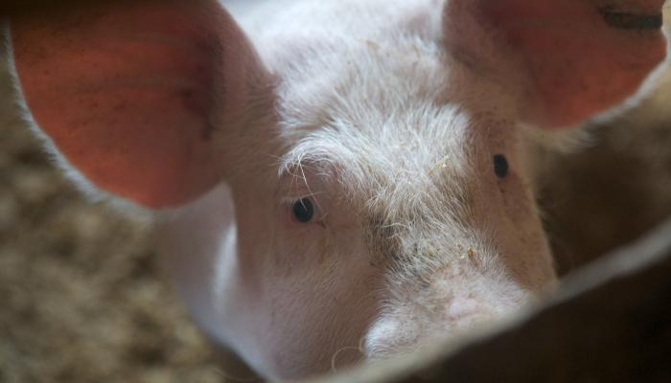
pelcinary / Flickr

While doing research for his book Pig Tales, author Barry Estabrook visited a farmer in Iowa who raised 150,000 pigs a year. What he saw at this factory farm -- the way 97 percent of pigs in the U.S. are raised -- is a far cry from Old MacDonald's.
"[The pigs] never see the light of day," he says. "They never set foot on anything but a bare, hard floor. They breathe that poisoned air 24/7."
What he saw is not only legal; it's state of the art. "This is the way pigs are raised," Estabrook says. [Find an excerpt from his book here.]
The pig, the wonder animal
Lynne Rossetto Kasper: You brand the pig "the wonder animal." Why?
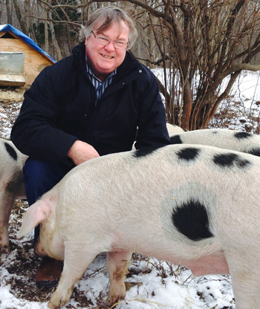
Barry Estabrook (Kathleen Frith / Glynwood)
Barry Estabrook: On many counts.
First of all, the sheer intelligence of pigs. Before I'd started my research, I knew pigs were smart. But just what they're capable of intellectually is beyond anything I suspected. They're as smart as a 3-year-old human being; there's scientific research showing that.
The second thing is that pigs have really been with us throughout our entire cultural revolution. From the minute we first abandoned being nomads as human beings 10,000 years ago, the pigs were there. They were helping us along. They helped us become who we are.
When we set out to explore North and South America from Europe, we couldn't have done that without pigs. On his second voyage, Christopher Columbus brought along a bunch of pigs to let loose on the island of Hispaniola to feed his crew. Even during the American Revolution our soldiers were fed dried pork; that's what gave them the strength to fight the war.
Pigs have always been here. They helped us open up the West. Early pioneers probably couldn't have settled down, except they brought a couple of pigs along with them.
LRK: Why the pig? What is it about the pig that made it so important in these situations?
BE: Primarily, no large domestic animal that we eat reproduces at anything close to the rate of a pig. A modern pig, a sow, can have up to 30 piglets a year born in two litters. Even in the old days, the original pigs that we domesticated would have six or eight piglets about every 8 or 9 months.
Compare that to a sheep, where you get maybe one or two lambs, or a cow, where you're lucky to get one. That cow would take 2 years to become slaughter size. A pig is ready to be slaughtered in 6 months. You can see that they're an incredible source of protein.
'This is the way pigs are raised'
LRK: Let's talk about where that supermarket pork chop comes from. You researched quite a few places that process pork. You talked to many people who had firsthand experience. What did you see and what did you learn?
BE: Perhaps my greatest education was one day in central Iowa, where I visited a single pig farmer who raised 150,000 pigs a year in 40 low-slung, warehouse-like confinement barns. We spent the day together.
Before we went into these barns, we both had to strip naked and take a thorough shampoo and shower, leaving our clothes behind. We passed through into this sterile zone to prevent disease from getting in.
The most memorable sight was when I went into a low, dark barn and saw 1,500 sows. These huge animals spent their entire lives inside metal cages that were so small the pigs couldn't even turn around. Their sides pressed out. They were like fat people on the middle seat of an airplane. Their sides pressed out through the bars. This is the way they lived their whole life, just producing piglets. They were like machines.
The smell hit me viscerally. It was like nothing I'd ever smelled. What I was breathing was ammonia and hydrogen sulfide. Those are poison gases.
LRK: Coming from the waste?
BE: Coming from manure, which is held in vast pits directly below where the pigs live. It would be the equivalent of filling your basement with sewage from your toilet and emptying your basement once a year.
These gases would kill the pigs, except there are huge fans on the ends of these barns that look like jet engines blowing that air out.
LRK: How do they survive under these conditions?
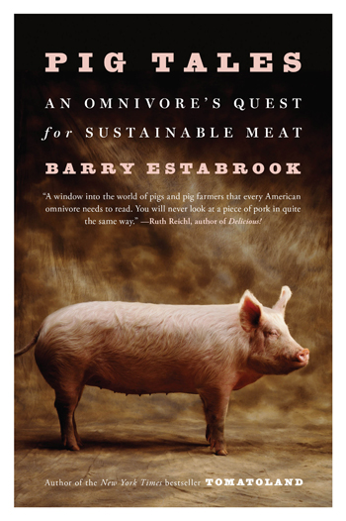
Pig Tales
BE: They're basically kept alive just long enough to reach slaughter weight. The fans keep them going, but much of it is because these pigs are fed constant, low-level antibiotics just to prevent them from getting sick. It'd be like you waking up every morning and taking an antibiotic even if you weren't sick. That enables them to live long enough to reach slaughter weight at 6 months of age.
LRK: This is the way commercial pork is produced?
BE: This is the way 97 percent of the pigs in this country today live. They never see the light of day. They never set foot on anything but a bare, hard floor. They breathe that poisoned air 24/7.
LRK: Aren't there laws against this?
BE: There would be laws against this if you did this to a dog. But no, there are no laws. This is all perfectly legal. In fact, it's state of the art. This is the way pigs are raised.
LRK: You talked about someone you met who was actually arrested for reporting this kind of situation, reporting what went on in these confinement areas.
BE: Yes. It was a man [Kenny Hughs] who lived in north central Missouri and worked at a farm that raised 2 million pigs a year. Imagine that.
He was fine with it until one day he encountered a sow that had gotten too old and had reached the end of her life. The attendants had simply pulled her out of one of those stalls, put another sow in, and left her lying in an alleyway in the barn to die. She couldn't walk. She was being given no food or water.
This fellow came back a couple of days later. She was in the same place but weaker still. He finally went to the head of the barn and said, "Do something about the sow. You can't do that." The guy told him to mind his own business.
That just infuriated this fellow. He went out to Walmart and bought a couple of those disposable cameras. He took pictures inside the barn of piles of dead piglets left there rotting; sows with enormous tumors the size of soccer balls on their shoulders; sows with open, gaping sores. It was horrific. Then he quit.
LRK: Where did the arrest come in? How did that come about?
BE: It was about the time that he was going to testify in a court case against this farm. All of a sudden he found that he was under arrest, accused of stealing some animal drugs from the barns. It was a total surprise to him.
After a year and his entire life savings, he was cleared in about 10 minutes by a jury because there was really no evidence. He thinks the pork producer was behind it. But of course there's no proof of that.
Manure rain: The environmental cost of factory farms
LRK: Just going back to the environmental side of this, you hear about "lagoons" that are attached to these pig factories and the kind of pollution problems there are. But what about the people who live near these places? That stench must carry, right?
BE: Calling them "lagoons" has to be one of the greatest euphemisms of all times. These things are cesspits. They're full of feces and urine, occasionally dead pigs and whatever else gets dumped in there. They're quite often black in color -- no blue lagoon or clear lagoon here.
Eventually they fill up. The way that farmers dispose of the manure in these lagoons is by spraying it into the air, in many cases in these huge "manure cannons," which look like giant lawn sprinklers. They blast it up into the air over the fields.
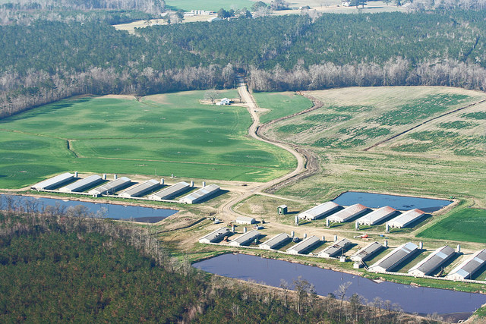
(Photo: Waterkeeper Alliance Inc. / Flickr)
LRK: Is this to fertilize?
BE: It's far too much. It's much more fertilizer than any field needs. That's the problem. It provides too much fertility to the soil. A lot of it washes off into rivers and streams. But much of it, as they're spreading it and spraying it, blows in the wind and comes across neighboring properties.
I spoke to one woman in North Carolina named Elsie Herring. The first time it happened to her, 20-odd years ago, she thought it was raining. It wasn't raining rain; it was raining something entirely different. It's to the point now where she can't really hang laundry outside. She's never sure whether she can mow the lawn. On a summer's evening, she can't sit on her porch and enjoy the cool air.
It's just a constant rain of this manure. It's poisonous. It contains hydrogen sulfide, which has been proven to raise people's blood pressure just by breathing it. It's not just a whiff of country air; it's a poisonous gas that's spreading across the land.
LRK: But what about protection from local government? This kind of thing ruins people's properties, it lowers their property value, and it's an intrusion.
BE: This particular woman and many others like her have been to every branch of local, state, and federal government and have gotten the runaround, no help whatsoever.
This is all legal. The problem is the laws governing agriculture date back to the days of Old MacDonald's farm, when you'd have a few pigs rooting around the back of the barn, not tens of thousands. The same laws apply, so they can do this legally. There's really nothing illegal about what they're doing.
LRK: I imagine the power of the pork producers is pretty strong in those environs.
BE: Politically, wherever pork is produced in large quantities, Big Ag is king. You think of states such as North Carolina, Iowa and Minnesota. Big Ag is a very, very, very powerful political force. It doesn't matter whether the politicians are Democrats, Republicans or Libertarians; they dance to the tune of Big Agriculture.
Confinement barns, slaughterhouses pose health risks for workers
LRK: What about the workers in these places?
BE: As you can imagine, the workers inside the barns suffer from a host of respiratory illnesses, diminished lung capacity and chronic coughing. If you have asthma to begin with, you can't work in one of those places, because you would have a seizure the minute you go in -- an attack. But you can develop asthma by working there. Even veterinarians who visit these places only occasionally have diminished lung capacity. Again, you're breathing poisonous gases.
The people who work inside hog confinement buildings are often exposed to deadly bacteria that have become resistant to antibiotics. They become resistant because these pigs are constantly fed a diet of low-level antibiotics. The germs that are resistant are the ones that survive and go on to breed.
A study done in Iowa a few years ago compared two groups of pig farmers. One group used antibiotics and another group didn't. Every one of the workers in the farms that used antibiotics were carrying something called MRSA [methicillin-resistant Staphylococcus aureus], a resistant staph bacteria that can be fatal. None of the farmers who didn't use antibiotics carried MRSA.
LRK: Is there any possibility that this also passes to the consumer who eats meat from such facilities?
BE: Yes, numerous studies of pork in supermarkets in the U.S. show that the meat is carrying not only MRSA, but several other resistant bacteria.
LRK: But would they disappear with cooking?
BE: If they're properly cooked, they would disappear.
But on the other hand, they're also carried in the environment. There has been much research done showing that MRSA and other resistant bacteria can be carried on the wind, they can be carried on dust, they can be carried on workers' clothes.
The other side of the coin is the people who work in the slaughterhouses where pigs are processed. Working in a slaughterhouse used to be a very good job. It used to be every bit as good, high-paying, as any manufacturing job and no more dangerous. But over the past 30 years, it's become one of the most dangerous jobs. The wages have fallen by about 40 percent. Working in a processing plant is also very dangerous.
Well-raised pork is more expensive, but is 'extremely good meat'
LRK: It cannot all be this black in terms of the pork industry. There have got to be other sides to this.
BE: The book does have a happy ending. There are an increasing number of people who are refusing to raise pigs according to the agricultural formula. They're raising pigs on pasture, allowing pigs to be pigs: to root, to roam, to form their own social groups, to feel the air on their backs, to wallow in mud. The result is a very well-raised animal that doesn't pollute and produces extremely good meat.
"Once you've tasted well-raised pork, you really can't go back to the old stuff. I tell people it's the difference between a January tomato in a supermarket and a nice summer tomato from your garden."
-Barry Estabrook
Ten years ago it was very difficult to find this meat, but increasingly it's getting much easier. You can find it at most farmers markets. Large national companies such as Niman Ranch distribute pork that's raised in this way.
The big benefit is the consumers get a really good product. Once you've tasted well-raised pork, you really can't go back to the old stuff. I tell people it's the difference between a January tomato in a supermarket and a nice summer tomato from your garden; factory pork and well-raised pork is that different.
LRK: What should you look for to find this pork? Is organic one of the assurances to look for?
BE: Organic, sadly, doesn't say a lot about how an animal is raised. It doesn't guarantee that it's been pastured and run free. You're better to look for people who actually claim that their meat is pastured, who advertise that their meat clearly is antibiotic-free, and preferably that it's been fed a vegetarian diet because commercial pigs can actually be fed rendered pig flesh.
LRK: In the book, you talk about a farmer who is raising his pork as you've described out in pastures. The pork is utterly delicious, but it runs close to $15 a pound. The average pork chop in the supermarket might be $3.50 a pound. This is where it gets tricky, because very few people can afford that more-expensive pork.
BE: It is more expensive, but I always use the example of the McDonald's Quarter Pounder: Fifteen dollars a pound for pork sounds expensive until you divide that figure by four. It comes to something less than $4. You realize that the Quarter Pounder meat you get in a McDonald's Quarter Pounder costs about the same amount. It's really how we perceive our food costs as much as anything.
But yes, it is more expensive because the old heritage breeds that produce this great meat don't have the number of piglets that an industrial sow will have. They're not raised in crates, so there's a greater chance that when the piglets are born, a sow may accidentally roll over and kill one. Once the piglets are growing, they grow more slowly than a commercial pig. They take maybe 8 months versus 6. The upside to that is a slow-growing pig produces very fine muscle fiber, which gives you tenderness and juiciness.
It goes right down the line. It costs more to get a pig slaughtered humanely in a small abattoir and butchered by professional meat cutters than it does to process a pig in one of these slaughterhouses that does 20,000 pigs a day -- a pig every 4 or 5 seconds. Right down the line, there are increased costs.
What you're paying for is meat that doesn't pollute the atmosphere. What you're paying for is knowing that the animals were well-raised -- they weren't submitted to these atrocious conditions. That the neighbors living near a small pig farm aren't gagging every time they go out to mow the lawn and aren't sickened. You're also paying for the fact that you're getting something really good, really tasty.
The three things to look for when you buy pork
LRK: When we're going to go out and buy our pork, what words should we be looking for on that label?
BE: I would say the easiest and a great starting point would be to look for pork that's clearly labeled "antibiotic-free" or "no antibiotics used." That, at least, is going to get you clear of the resistant antibiotic issue. It'll often mean that the farmer had to raise the pigs under better conditions.
A second thing I would look for is a farmer who says that his pork is "pastured," meaning that it's raised outside and not in one of these confinement buildings.
A third thing you might look for is "organic." Organic animals don't get antibiotics. They're also not fed slaughterhouse byproducts in their food.
From This Episode:
Factory Farm
Published:
May 6th, 2015

