QUARTZ.COM

The world eats cheap bacon at the expense of North Carolina’s rural poor
WRITTEN BY Lily Kuo
July 14, 2015
Duplin County, North Carolina

The first thing Violet Branch does when she wakes up is to inhale through her nose to see whether the smell of hog excrement from across the street has seeped into her home again.
“Sometimes when I wake up the odor is in the house. Sometimes before I go to bed, the odor is in the house,” says Branch, 71, who lives next door to a swine farmer who keeps two lakes filled with a swampy mixture of feces and urine that he periodically spreads on his crops as fertilizer. An acrid odor of rotting eggs fills her yard at least twice a week and occasionally her home, giving her nausea and on some occasions causing her to vomit. All she can do is wait until it passes or ask her son who lives next door to drive her to the nearby Walmart where she paces the aisles until her breathing returns to normal.
Branch, wearing tiger-striped reading glasses and a mustard-colored sweatshirt, sits in the kitchen of her small one-story home crowded with pictures of her grandchildren and her parents who ran a farm here in Warsaw, 50 years ago while raising Branch and her 10 siblings. When asked about the lawsuit she has filed against hog production giant, Murphy Brown, which buys from the hog grower across the street, she says, “You ever hear that saying, ‘What comes around goes around’?”
Branch is one of over 500 residents in eastern North Carolina who are suing Murphy Brown, the pork production arm of Virginia-based meat conglomerate Smithfield Foods. They’re seeking damages over the cesspools, or lagoons as the industry calls them—uncovered earthen storage pools of waste. The complainants say the lagoons disrupt their lives and devalue their properties.
“The poor people, they literally get shit on.” One couple alleges they were forced to close their family business, a restaurant, because the smell drove customers away. Another complainant says he and his wife are so embarrassed by the odor that they no longer have friends over. Others claim that when the farmers spray the waste from the lagoons onto crops, a fine mist of liquefied feces collects on their houses and cars, attracting swarms of flies. Some say their children get teased at school because their clothes smell like hog manure.
The lawsuits mark the latest chapter in a decades-long battle. To outsiders, it may look like little more than a spat between neighbors. But at heart, it’s a story about poverty and racial inequality, and how those forces play out in a state where the hog industry has emerged as both essential for the economy and an oppressor of poorer communities of color.
It begs questions about the quality of life the world’s richest nation will tolerate for its poorer citizens, questions that have been thrown into sharp relief by the recent entry into North Carolina of China’s—indeed the world’s—largest pork processor, WH Group. Drawn by the low cost of production there, WH Group finds it cheaper to raise pigs in North Carolina and export them to tables back home than to raise the animals in China. The irony is not lost on the residents of Duplin County.
“The poor people, they literally get shit on,” says Kemp Burdette, who advocates for better water quality in North Carolina’s Cape Fear River with the nonprofit, the Cape Fear River Watch.
Above swine country
Flying from North Carolina’s coast toward Duplin County, the change in landscape is dramatic as you enter hog country. Old colonial-style houses, swimming pools, shopping centers, and golf courses give way to a flat patchwork of green and brown fields dotted with trailers, long metal barns, and the telltale sign of a hog farm—dug out basins filled with a murky liquid tinged a purplish-pink, the result of bacteria consuming the swine waste stored in them. North Carolina has thriving tech, pharmaceutical and banking sectors and a richly-endowed university system, but you wouldn’t know it here.
Almost a quarter of the population lives below the poverty line, making Duplin County one of the poorest counties in North Carolina. It is also disproportionately black and Hispanic compared to the rest of the state.
Since the late 1990s, Duplin has been the top hog producing county in the country, and a big reason why Americans can buy their pork for as little as $2.50 per pound. Home to about 530 hog operations with capacity for over 2 million pigs, it has one of the highest concentrations of large, tightly-controlled indoor hog operations, also known as CAFOs (concentrated animal feeding operations) in the world. Here in Duplin, hogs outnumber humans almost 32 to 1.
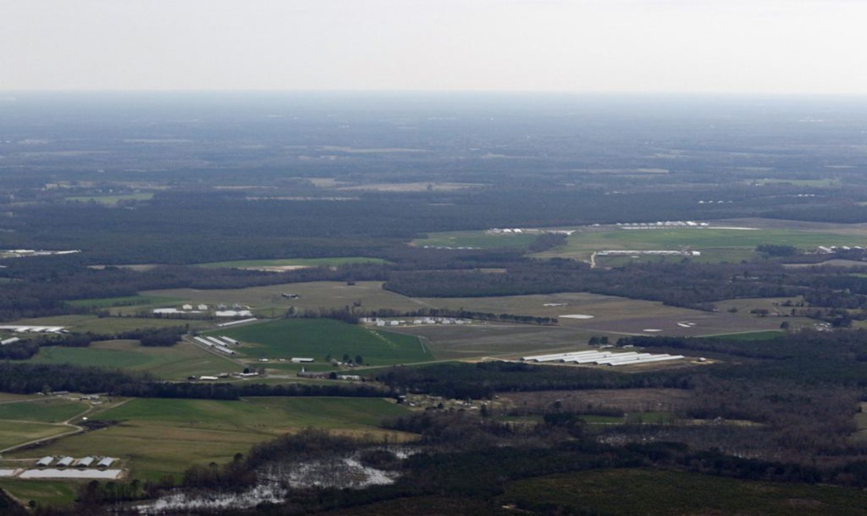
An aerial shot of hog farms and lagoons near a creek in Duplin County. (Waterkeeper Alliance/Larry Baldwin)
Pork has always been important to North Carolina’s economy. It was among 16 commodities used as legal tender by colonists in the early 1700s, and for almost as long, farmers and their neighbors have been fighting over how the animals should be managed. Today, the industry accounts for close to $8 billion a year in revenue and 46,000 full-time jobs in production and processing, according to the North Carolina Pork Council, making the state the second largest pork producer in the US.
Accompanying all those swine is a lot of waste—hogs produce two-to-five times as much waste as humans. North Carolina does not release exactly how much manure is produced a year, and Smithfield declined to disclose how much its pigs produce, but estimates range between15.5 million tons (pdf, p. 5) for the state’s top five pork producing counties to 2.53 billion gallons for the whole state. The nearly 2.3 million hogs raised in Duplin County generated twice as much waste as the entire city of New York (p.11) in 2007, the nonprofit Food and Water Watch estimates.
Hog wars
Residents, the industry, and its critics have been at an uneasy stalemate over the lagoons for the past fifteen years. Big industrial farms first started popping up in the 1980s. By the late 1990s, public concern turned to outrage when a series of lagoons overflowed during storms, submerging entire towns in waste. After that, armed protestors blocked construction of a new farm in Craven County, northeast of Duplin, and two hog farms in a neighboring county were riddled with bullet holes. But it wasn’t until a new hog farm and lagoon was proposed near the wealthy North Carolina golfing village, Pinehurst (right before it was to host the 1999 US Open), that lawmakers finally passed a statewide moratorium on the opening of new hog sites. The ban remains in place today.
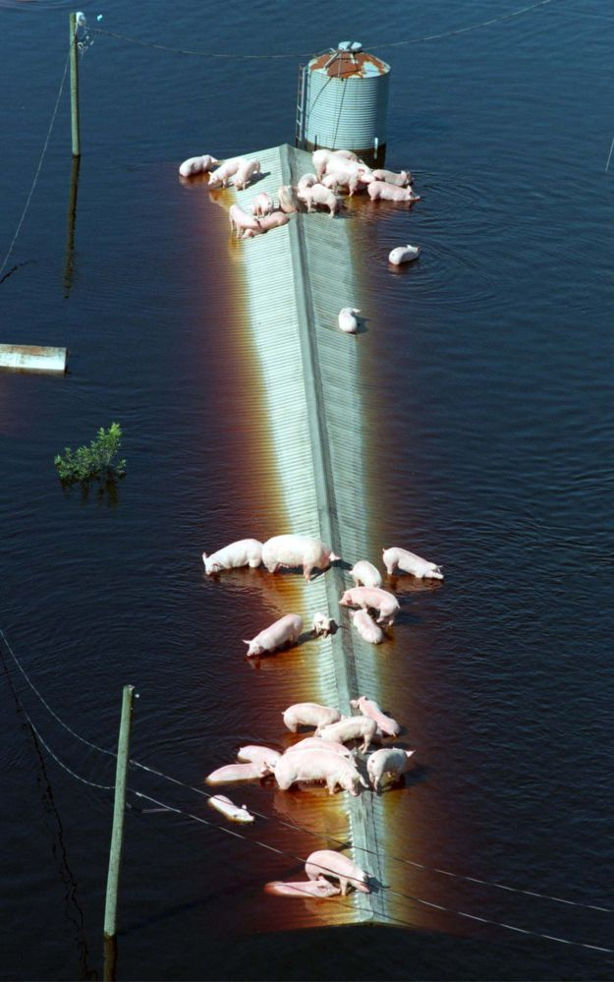 Pigs from a hog farm near Trenton, NC, wait for rescue after Hurricane Floyd landed near Cape Fear in 1999 and caused lagoons to overflow. (Reuters/Stringer)

Smithfield representatives say the company has gone beyond meeting state regulations on waste processing by setting up internal audits and reporting systems that provide local residents with a mechanism to file complaints. In 2000, Smithfield told the state it would spend $17 million researching waste management alternatives, with the aim of implementing new, “environmentally superior” technologies. But 15 years later, the lagoons remain. Legislators deemed that the alternatives—which cost as much as five times the current lagoon system—were too expensive to force Smithfield and local farms to adopt. Today, almost all of North Carolina’s 2,100-plus hog farms still store their waste in open lagoons, which can be as large as a football field.
“Industry is unhappy because they would like the ability to expand and build new farms and the environmentalists are unhappy because we still have these lagoons operating out there,” says Kelly Zering, a professor at North Carolina State University, who led part of the economic analysis of the alternative technologies in the Smithfield-funded research initiative.
The stalemate was broken in 2013 when the Chinese company Shuanghui, now known as WH Group, acquired Smithfield for $4.7 billion. The deal, the largest Chinese takeover of a US company ever, placed a national spotlight on pig farming, and provided plaintiffs with fresh impetus to revive their complaints about the lagoons.
Smithfield says the acquisition has made it a target for lawyers hoping for “a quick payday.” The first lawsuit arrived just two months after the takeover was announced in May, the company’s legal counsel points out. “This was out of the blue,” says Mark Anderson, Smithfield’s counsel. There were few records of the residents complaining to neighbors, the state, or to the company before then, he says. “Whether we’re right or not, we read into that a purpose.”
Parent WH Group also dismisses the nuisance claims. The company told Quartz that it is “aware of the allegations,” adding that “based on what we know now, we find them to be either wildly exaggerated, or in most cases, wholly unfounded and frivolous.”
The complainants say they have been raising their concerns to officials and the company for years. Branch, for example, has been a thorn in Smithfield’s side for the better part of the last two decades, rallying others through local community groups and making media appearances. Less vocal residents say they have been complaining for years as well.
Lakes of manure
The noxious odors are apparent to anyone traveling through hog country—one of the plaintiffs likes to joke that you can smell the city of Beulaville, in Duplin County, long before you get there. But not a whole lot is known about the health and environmental effects of the lagoons.
Historically, there has been little research into claims that they hurt the health of people living or working near them through water or air contamination. Studies have mostly focused on the efficiency of hog production rather than negative side effects that could create liabilities or expenses for the industry, according to Steve Wing, an epidemiologist at the University of North Carolina at Chapel Hill (UNCCH). But in recent years, environmentalists, academics and public health advocates have begun documenting their impact.
Studies point to effects from impaired memory to higher infant mortality rates, wheezing, nausea, and higher blood pressure. The technology behind the lagoons is rudimentary at best. The hogs defecate in their indoor stalls, their waste falling through slatted floors into slurries where it is flushed or pumped into a nearby lagoon. Solid waste forms sludge at the bottom of the basin, creating a semi-permeable barrier that helps prevent leakage into the ground. Liquid from the top of the pond is used as manure, and applied to crops with high-pressure spray guns. Unlike human waste, which is processed in municipal wastewater plants, the only treatment the pig manure receives is through exposure to naturally occurring bacteria in the lake.
Local environmentalists argue that in eastern North Carolina especially, a swampy wetland where the ground water tables are high, waste runs off of the spray fields into ditches that lead into creeks and major streams like the Cape Fear River. A study released in January by researchers at the University of North Carolina and Johns Hopkins University found elevated levels of hog-related fecal bacteria—which can cause hepatitis, typhoid, dysentery and other health problems—in waterways near hog operations.
A new study released in June by the US Geological Survey found that 21 of 36 watersheds in eastern North Carolina with swine or poultry CAFOs showed higher levels of nutrients and major ions than those without. Other studies point to effects ranging from impaired memoryfunction to higher infant mortality (paywall) rates; higher asthma rates in children to wheezing, nausea and higher blood pressure among the neighboring population.
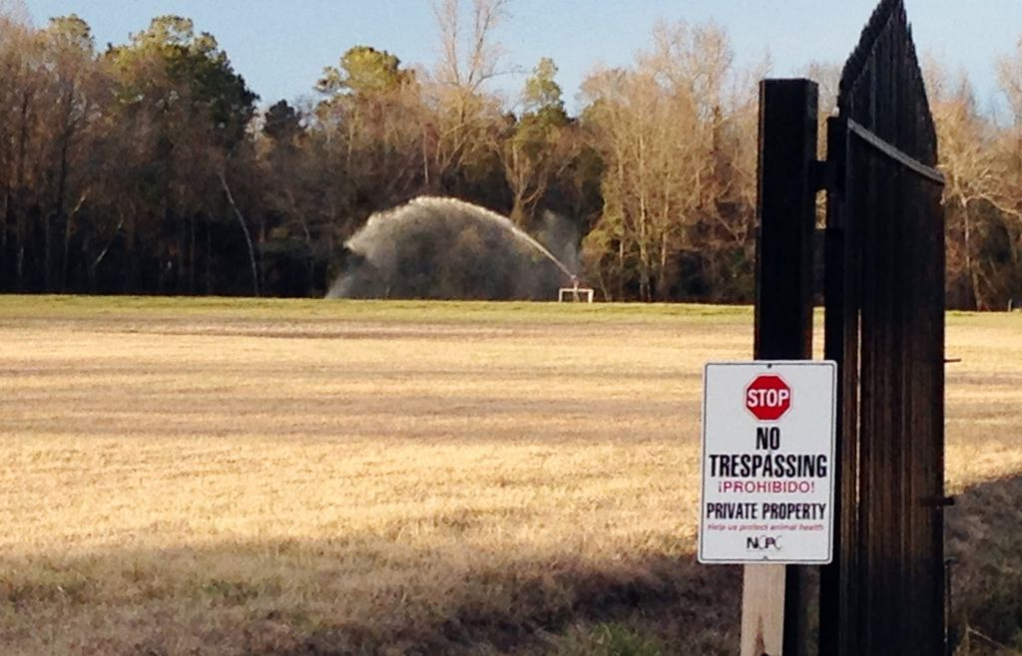A sprayer soaks a field with liquified manure and urine from a large-scale hog farm in Duplin County, North Carolina.(AP Photo/Emery Dalesio)
“These lagoons and spray fields cannot be allowed to continue in North Carolina, they are causing too many problems to our waters, our air, our people, our health. They have got to go,” says Rick Dove, a local activist with the Waterkeeper Alliance in New Bern, North Carolina and long-time campaigner against the lagoons.
The industry argues that few studies show a direct link between hog CAFOs and harm to people’s health or the environment. Pollutants can also come from other sources like fertilizer, municipal human waste, or wildlife, they point out. They say that the lagoons, if maintained properly, can last forever and pose little threat to the environment or nearby residents. According to a 2008 Government Accountability Office survey, 53 of 68 government-sponsored or peer-reviewed studies failed to directly link air and water pollution from animal waste to environmental and health problems. Although the remaining 15 do show a link, they’re not sufficiently damning to force hog producers, or the state for that matter, to do more.
North Carolina state officials agree with the hog producers that the lagoons are safe and that the regulatory system in place is more than enough to mitigate any potential impact of the farms. Swine farms must have permits, approved waste management plans, detailed logbooks of how many times they fertilize the crops as well as soil samples to ensure they’re not over-applying. Farmers also have to maintain “freeboard” of at least one foot between the liquid waste and the top of the lagoon to prevent overflow during storms.
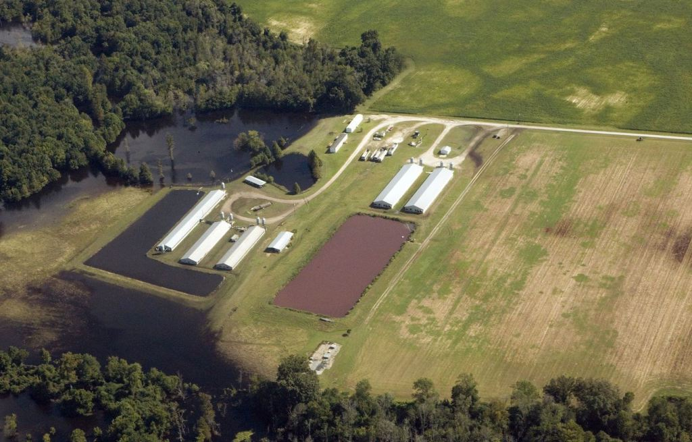A hog lagoon in Duplin County, North Carolina. (Waterkeeper Alliance/Larry Baldwin)
“North Carolina has a robust, comprehensive program to regulate animal operations and is the only state in the nation that requires annual inspections of every facility,” said Susan Masengale, a public information officer with the state’s Department of Environmental and Natural Resources (DENR), which regulates the lagoons.
There’s little federal oversight of these operations. Only 40% of 20,000 large livestock operations in the US are regulated under the Clean Water Act, the federal law on water pollution, Jon Devine, a senior attorney for the National Resources Defense Council, told National Geographic last year. That’s because only CAFOs that are designed to discharge directly into streams or other water sources are required to apply for federal permits under the Clean Water Act.
Environmental racism
Elsie Herring, one of the complainants, says that living next to a hog farm made the last years of life for her mother and brother hard. Herring lives in the town of Wallace, in Duplin, where she and her siblings grew up on land that her grandfather, a freed slave, had bought in 1891. Her mother died in 2001; her brother, who had Down syndrome died in 2006. During their last few years, Herring avoided letting them sit outside when the farmer next door was spraying waste from his lagoon onto crops. The odor, she said, would drift over and give them breathing problems.
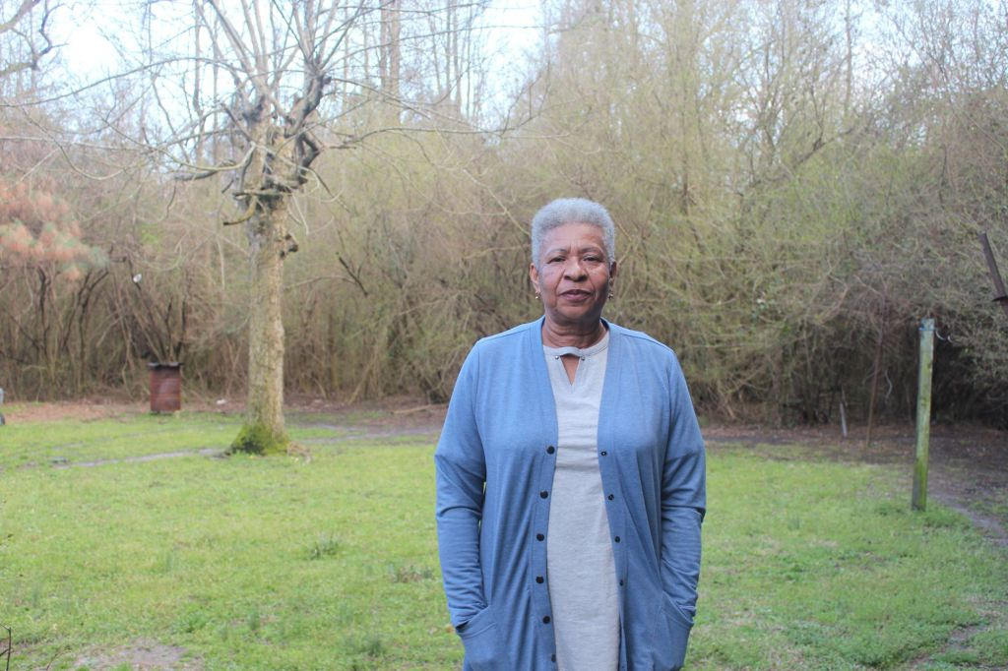Elsie Herring, in Wallace, North Carolina, is one of the complainants suing Murphy Brown. (Quartz/Lily Kuo)
Herring didn’t have the time or money to drive her mother elsewhere, so she could escape the smell. “My mother, all she could do was get out and walk around outside,” Herring says from inside her living room. The room, dotted with candles and air fresheners, also has an air conditioning unit, an expense says Herring, that she’s forced to incur because she can’t leave her windows open now.
“Sitting on the porch, walking outside or going outside to visit my sister and nephew should have been something they were able to do as long as they were able to do it,” she says, gesturing across the gravel driveway in front of her house. “But because of the hog waste, the last years of their lives they were held prisoners in their own home.”
There is little denying that whatever the impact of the hog lagoons, it is poorer rural communities of color that bear the effects the most. Almost all of the plaintiffs in the nuisance lawsuits are black Americans. A study released last year by UNCCH found that black North Carolinians were one and a half times as likely to live within three miles of an industrial hog operation as white residents. American Indians were twice as likely and Hispanic residents were 1.39 times as likely to live near these facilities in North Carolina. “This spatial pattern is generally recognized as environmental racism,” the study’s authors concluded.
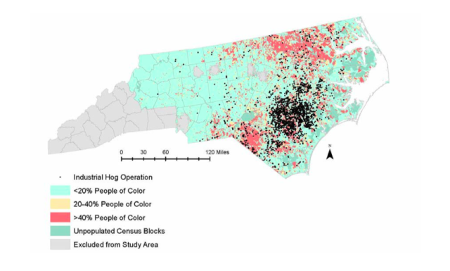("Industrial Hog Operations in North Carolina Disproportionately Impact African-Americans, Hispanics and American Indians," Steve Wing and Jill Johnston)

“There is a lot of distrust between Latinos, blacks, and the industry,” says Devon Hall, a community organizer of the group, Rural Empowerment Association for Community Help, also known as REACH. “For so long, our concerns have been downplayed, but when we hear the powers that be say, ‘It’s not that bad,’ it is always someone who doesn’t have the same skin complexion as myself,” Hall says.
For some of the plaintiffs, the worst part is feeling ignored and helpless. Al Davis, 69 lives with his wife and two sons in Beulaville, about 54 meters (177 feet) from a field where waste from a hog farm of 4,740 swine is spread. Davis, retired after years of working as a technician at a textile mill, would like to pass on the land that he’s owned for the past 44 years to his sons but worries the value of it is too low now. He’d like to take up gardening but the odor makes it hard for him to breathe when he’s outside. Having a cookout, taking his youngest son to play outside, or just sitting out on his porch are also out of the question.
“It’s a bad feeling,” Davis says. “I just feel powerless, frustrated.”
The world’s largest pork consumer
China’s arrival in North Carolina’s hog industry has aroused fear among local residents, but also provided critics of the lagoon system with fresh ammo. They argue that Smithfield, under Chinese ownership, will have to produce more pork to feed growing demand for the meat from China’s expanding middle class families, and that will mean more hogs and more waste.
For now, it is far from certain that will happen. Lawmakers have approved a bill that would allow some previously closed hog farms to reopen and use lagoons, but for now the moratorium and a quota system on the number of hogs per farm remain in place. One way farms can get around the restrictions, according to Zering, the NCSU professor, is by raising heavier hogs, which produce more waste. There’s data to support that thesis: Today, the average market hog in North Carolina is 27% heavier than it was in 1980. But fatter pigs, on their own, without any changes to the moratorium or quota system won’t move the needle much.
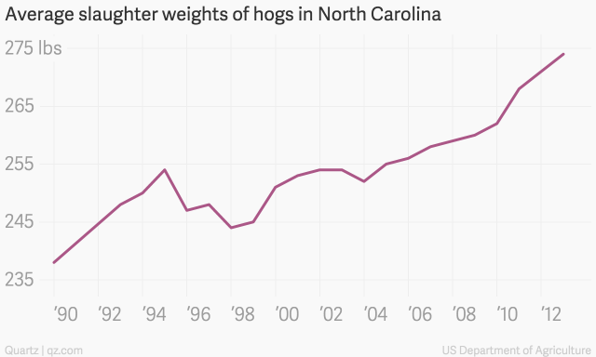According to government data, the average hog weight when slaughtered in 2013 was 36 pounds heavier than in 1990.
What is clear is that mistrust and a certain amount of xenophobia have complicated an already controversial issue. China’s role in the US hog industry is so polarizing that Smithfield’s lawyers have filed a motion to strike mention of “the Chinese government, Chinese corporations, and Chinese demand for and purchases of pork” from all proceedings in the nuisance suits. The lawyers argue that these references are “scandalous and clearly designed to inflame the jury and the public while taking advantage of xenophobic biases in today’s political landscape,” according to their court filing.
It’s undeniable that WH Group and Smithfield benefit from the low-cost lagoons. Today, raising hogs somewhere like North Carolina is almost 50% cheaper than in China where hogs are still bred on thousands of small farms. Lagoons, which require little manpower to operate, along with cheaper feed in the US, and the use of larger and more efficient CAFOs have helped lower costs. The average hog production costs in China more than doubled between 2002 and 2009. But in the US those costs fell by over a quarter (p. 24) between 1998 and 2009 as industrial hog farming and the accompanying lagoon system got underway in places like North Carolina.
Even Smithfield’s corporate owner in China uses what lagoon skeptics would call more advanced technology that North Carolina lawmakers deemed too expensive to force farms to use. WH Group’s seven pork farms in China—which produced just 311,000 sows last year, compared to Smithfield’s 14.7 million—use a dry manure removal process that separates the solids from the liquids and stores them in oxidized lagoons. Two of the farms use a digester system where the lagoons are covered and used to generate electricity.
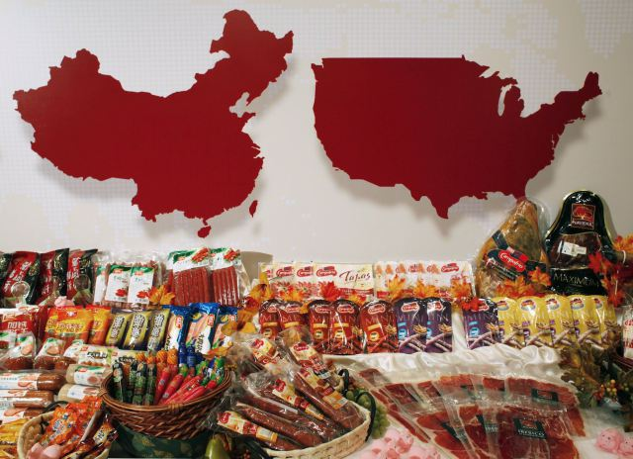Products of WH Group are displayed in front of maps of China (L) and the United States at a news conference about the company’s IPO in Hong Kong in 2014. (Reuters/Bobby Yip)
In fact, finding new technologies that cut down on odor and potential leaks into water sources has become a national priority for the country. A pollution census in 2010 found that agricultural pollution, and especially manure from livestock operations, was a larger source of water pollution than industry. Since then, China’s ministry of agriculture has been promoting the use of biogas digesters.
All this bolsters arguments that poorer agricultural communities in eastern North Carolina are fast becoming China’s outsourced factory farms. “Water and air pollution, emissions of noxious gases… All of those things are here. We’re getting all of those negative impacts and all of the profits are going to China, and a lot of that meat will go to China,” says Burdette, the water advocate for the Cape Fear River.
Raising hogs somewhere like North Carolina is almost 50% cheaper than in China. Through its ownership of Smithfield, WH Group effectively owns one in four pigs raised in the US. It’s an ironic reversal of roles in global trade, given American consumers’ presumption that it is they who benefit from cheap products manufactured by low wage workers in China.
“Historically, the rich countries have been able to get natural resources and cheap labor from poorer countries. Now what’s happening is you have a company…that is producing in a way that destroys the health and environment in a rich country,” says Wing, the epidemiologist from UNCCH.
There are other alternatives
If Smithfield spent or required its contract farms to spend an additional $52,000 per average farm—the cheapest alternative option that researchers came up with during the Smithfield-funded initiative in 2000—it could dispose of its farms’ hog manure in less odorous ways.
In fact, its farms in other states are already using some of these technologies. In Utah, Smithfield uses “anaerobic digesters,” or covered lagoons in which methane is captured and used to generate biogas. (Hog farms in Germany, the European Union’s largest hog producer, use this method.) Smithfield says the project should eventually produce about 25,000 megawatt hours of electricity a year. In Missouri, some Smithfield farms have also installed lagoon covers to capture biogas, as well as barn scrapers that shovel the waste into storage units or a lagoon rather then flushing it out with water, which helps cut down on odor and emissions (pdf, p.21).
Why doesn’t Smithfield go ahead and adopt some of these technologies in North Carolina? “We’re rich and big and how come we just don’t do it? The answer is we’re also a for profit company that has an obligation to shareholders,” says Smithfield’s chief sustainability officer Dennis Treacy. He says the lagoons are “state of the art” and will not be going anywhere soon. “We constantly are looking for ways to change and have changed dramatically, but to do it willy-nilly, based on the whim of a scientist or a public opinion piece that shows up somewhere, we really have to take a hard look at that.”
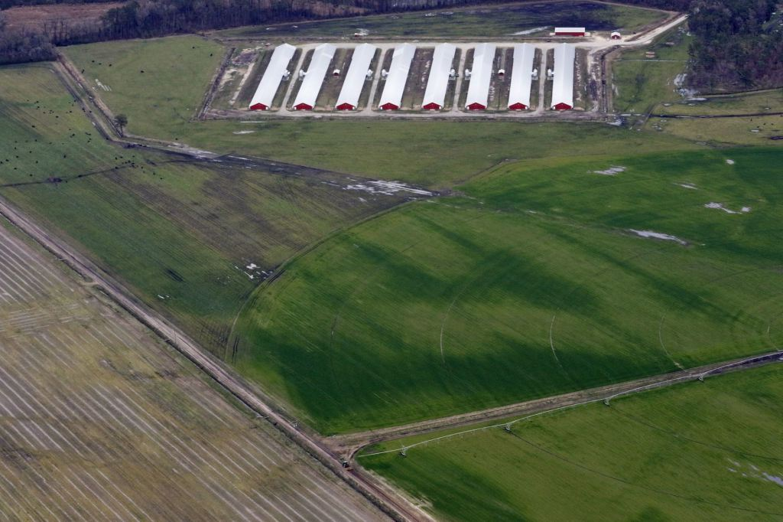A spray field where hog waste is applied as fertilizer. (Quartz/Lily Kuo)
But even experts who contributed to the conclusion that these alternative technologies are too expensive say the lagoon system can’t last forever. As global meat consumption grows, and its production is increasingly concentrated in massive, industrial farms, the US and and other countries will have to deal with rapidly growing quantities of animal waste. Iowa and Minnesota, other major US hog producers, face water quality and air pollution issues similar to those in North Carolina. Health experts in China, where the hog industry is expanding in hopes of gaining pork self-sufficiency, worry that more porcine waste is increasing antibiotic resistance in humans (pdf).
“When [the lagoon system] was incorporated in the 1970s and 1980s, it was a really good model, but I feel it is not the model that can take us into the future,” says Mike Williams, director of the Animal and Poultry Waste Management Center at NC State, who headed the Smithfield-funded research initiative. “It is not sustainable for many generations from now,” he says.
Taking sides
It’s unlikely the fighting over hog lagoons in North Carolina will be settled soon. The state is neither funding nor forcing companies to fund further investigations into alternative models. Despite the fact that there are more studies documenting the lagoons impacts as well as other options, overhauling the lagoon system isn’t high on the government’s list of priorities. “Most people are going on with their daily lives, not thinking about hog pollution,” Dove says.
The state’s General Assembly has proposed rules that would bar new residents in a neighborhood from filing nuisance lawsuits. Another proposed amendment would require residents who lose their nuisance cases to pay for the legal expenses of the farms sued. The state is getting a little less transparent—as of last year, the state government will no longer disclose how many total complaints have been made against hog farms. Instead, North Carolina only reports those that resulted in notices of violation. (Between the start of 2012 and the end of March this year, there were only 15 notices.)
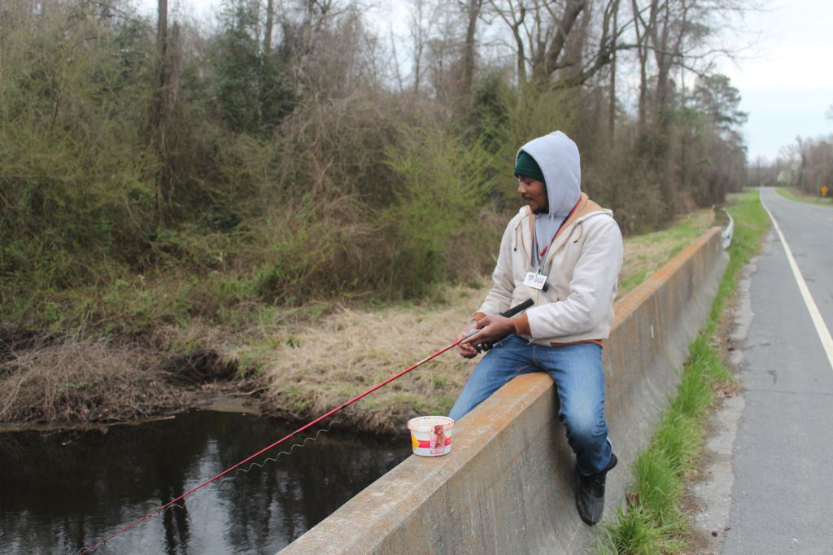Marcus Childs, a Duplin County native, fishes on Maxwell Creek, a stream surrounded by several hog farms. (Quartz/Lily Kuo)
Within the community, divisions have started to form. The prevalence of the hog industry in counties like Duplin means that almost everyone is connected to the swine business. Hog farmers say that a hit on Murphy Brown, which owns or contracts with as many as two thirds of farms in the state, would affect them too.
“If [Murphy Brown] loses, what they lose has got to hurt me, and all the guys working out here,” says Ronnie Wezzel, 65, who works on a Murphy Brown farm in Warsaw, in Duplin County, near one of the complainants.
“We here in Duplin County are fine and would appreciate if others who don’t like our way of life stay where they come from.” Marcus Childs, 20, another Duplin County native, knows which side of this argument he sits on. A hanger at a local poultry processing plant, he spends his days on an assembly line slinging birds on to metal hooks. One mid-morning day in late March, he is fishing for bream and catfish by Maxwell creek, a stream in Duplin County flanked by hog and poultry farms.
Childs says he is not concerned about the possibility of manure contaminating the water—he catches and eats fish from these streams two or three times a week. The smell of the hog waste doesn’t bother him either. “It’s like money to us,” he says.
Others prefer to think of the plaintiffs and critics of the industry as outsiders, attacking an economy and way of life they don’t understand. Amanda James is president of Rose Hill Magnolia Elementary—a primary school located just behind a rendering plant in Duplin County that turns unwanted animal parts into feed and other products. She says the plant does a good job of minimizing the odors it sends into the air. “Not to mention the thousands of jobs that are provided to so many families in the area because of our hog farms,” she says.
“We here in Duplin County are fine and would appreciate if…others who don’t like our way of life stay where they come from and quit trying to disturb our way of life,” James adds.
Why don’t they move?
It might look like the cards are heavily stacked against the residents of hog country, but legal experts say that there is more public scrutiny of the industry now, as well as as more community activism than before.
“Things are different. There’s more general awareness of the problem and a lot more scientific study of the human and environmental impacts,” says Michelle Nowlin, a supervising attorney with the Environmental Law Clinic at Duke University.
Residents’ greatest hope of remedy may rest in federal law that has nothing to do with farming, health or the environment, but exists to serve vulnerable populations: The Civil Rights Act. A group of non-governmental organizations, the North Carolina Environmental “I think about how long I’ve been here, and I think about how pleasant it was…How come they don’t move?” Justice Network, REACH, the Waterkeeper Alliance, and Earth Justice have filed a civil rights complaint against the state agency DENR for the hog lagoons’ “unjustified disproportionate impact on the basis of race and national origin against African Americans, Latinos and Native Americans.” The EPA has said that it would investigate the accusations. The federal agency could pull its funding for DENR or force it to change its permitting system.
If the nuisance lawsuits are successful, litigants could win monetary damages equal to the value of their homes and more. The plaintiffs are not demanding injunctive relief, which would require the farms to cease using the lagoons. The lawsuits should take another two years to reach a conclusion, Smithfield’s lawyers estimate.
Some of the complainants may eventually move. But not all of them will. Branch, sitting at her kitchen counter in Warsaw, reminisces over her childhood and raising her daughter on the same land her parents farmed. “I think about how long I’ve been here, and I think about how pleasant it was,” she says.
She gets angry at any suggestion that she leave to avoid the smell. “When I’m asked that question it stirs up something in me. It doesn’t make me feel happy at all,” she says. “How come they don’t move?”
http://qz.com/433750/the-world-eats-cheap-bacon-at-the-expense-of-north-carolinas-rural-poor/

