Food Safety News

2014 in Review: Animal Antibiotics
BY LYDIA ZURAW | DECEMBER 22, 2014
Food Safety News wrote a lot about antibiotic resistance this year — particularly the debate surrounding the Food and Drug Administration’s (FDA) plan to phase out the use of certain antibiotics in food animals, introduced in December 2013, and conversations sparked by the 16-month outbreak of multi-drug-resistant Salmonella Heidelberg linked to Foster Farms-brand chicken that ended in July 2014.
As the year draws to a close, we thought it would be worthwhile to recap what happened in the past 12 months regarding animal antibiotics.
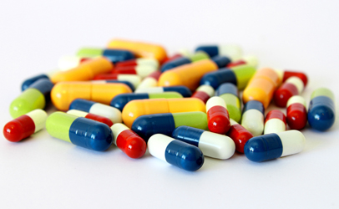
Frequent readers will know that the Centers for Disease Control and Prevention (CDC)estimates that antibiotic-resistant infections sicken at least 2 million people every year and that more than 23,000 die as a result.
Although the majority of these infections occur in healthcare settings, concern is growing over antibiotic-resistant infections from food and the contribution that subtherapeutic antibiotic use on farms (meaning below the dosage levels used to treat diseases) makes to resistance.
Each year, antibiotic-resistant infections from foodborne germs cause an estimated 430,000 illnesses in the United States. Multi-drug-resistant Salmonella, from food and other sources, causes about 100,000 illnesses in the U.S. each year.
Antibiotics are commonly used to promote the growth of food-producing animals and to prevent, control and treat disease. Overuse on farms can lead to resistant bacteria that cause infections in both animals and humans and could spread resistance genes from animal bacteria to human pathogens.
By some estimates, about 80 percent of antibiotics sold in the U.S. are used in animals, though FDA cautions that it’s difficult to draw conclusions from direct comparisons between human and animal data because of differences such as population size (number of people compared to the number of animals in each of the many veterinary populations).
“The good news is, in the past year, there has been an absolute explosion of research and press coverage and public awareness about the prevalence of antibiotic-resistant superbugs,” U.S. Rep. Louise Slaughter (D-NY) told participants in the Supermoms Against Superbugs advocacy day held this past May in Washington, D.C. “The bad news is the crisis is getting so much worse and the pace is quickening.”
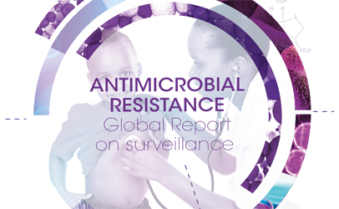International efforts
A huge antibiotics story of 2014 was the report released by the World Health Organization (WHO), which found that there are very high rates of resistance in bacteria that cause common health-care-associated and community-acquired infections in all WHO regions, and that antibiotic resistance surveillance “is neither coordinated nor harmonized, compromising the ability to assess and monitor the situation.”
Over the summer, France published an assessment of the risks of emerging antimicrobial resistance related to patterns of antibiotic use in animal health, following that government’s decision to reduce the use of antibiotics in veterinary medicine over the 2012-2017 period (the Ecoantibio 2017 plan).
Sweden challenged the European Union to match its own livestock-welfare standards, which include medicating animals only when they are ill.
And the Netherlands hosted an international conference on antibiotic resistance as a followup to the WHO report. During her address, Dutch Minister of Health, Welfare and Sport Edith Schippers said that, “When it comes to agriculture — it is my firm belief that we should ban the use of our last-resort antibiotics in animal husbandry all together.”
The U.K.’s Review on Antimicrobial Resistance, established at the start of July, released its first report in December, projecting that a continued rise in resistance would, by 2050, lead to 10 million deaths every year and a reduction of 2 to 3.5 percent in Gross Domestic Product (GDP).
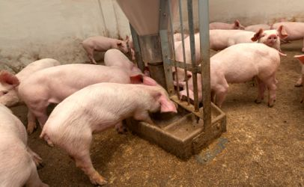FDA policies
The main topic of conversation in the U.S. was FDA’s Guidance for Industry #213, which asks animal pharmaceutical companies to remove growth-promotion claims from medically important antimicrobial drugs in food-producing animals, and the agency’s proposed rule implementing the Veterinary Feed Directive (VFD), which aims to ensure that the products can no longer be used without veterinary oversight.
The guidance is voluntary, and, by March, FDA heard from all 26 affected sponsors that they intend to comply. To date, 32 of the 292 affected products were withdrawn from the market.
Despite the companies’ commitment to the plan, many public-health advocates worry that the drugs will be re-listed with new “disease-prevention” labels and still be used in the same way.
The Keep Antibiotics Working (KAW) coalition has raised concerns that FDA isn’t policing extra-label marketing for growth promotion.
In July, Sens. Elizabeth Warren (D-MA), Kirsten Gillibrand (D-NY) and Dianne Feinstein (D-CA) wrote to FDA Commissioner Margaret Hamburg with their questions about how the agency will monitor success of the guidance and ensure compliance with the VFD.
And, in December, a year after FDA announced its plan, The Pew Charitable Trusts released an analysis claiming that gaps in the policy could allow for some drugs to be used for disease prevention at the same levels as growth-promotion doses and without a limit on duration.
Responding to questions from Warren about Guidance #213 during a Senate Committee on Health, Education, Labor and Pensions (HELP) hearing in March, Hamburg said she believes it will make “a real and an enduring difference.”
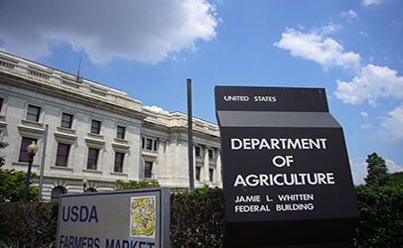Other agency news
In July, the U.S. Court of Appeals for the Second Circuit in New York ruled that FDA is not required to hold hearings to determine whether to withdraw approval for the use of penicillin and tetracyclines in animal feed. That decision overturned two district court rulings from 2012 in a case initially filed in 2011 by the Natural Resources Defense Council (NRDC), the Center for Science in the Public Interest, Food Animal Concerns Trust, Public Citizen, and the Union of Concerned Scientists.
Also over the summer, the U.S. Department of Agriculture’s Food Safety and Inspection Service (FSIS) denied the Center for Science in the Public Interest’s three-year-old petition to have antibiotic-resistant Salmonella declared an adulterant, stating that more data are needed. A few months later, CSPI submitted a revised petition.
In October, FDA released its 2012 Summary Report of the information animal-drug sponsors are required to report every year. According to the data, sales of medically important antimicrobials used in food-producing animals in the U.S. increased by 8 percent in 2012 and by 16 percent between 2009 and 2012.
Public-health stakeholders were pleased to see more details about the data — the importance of each drug class to human medicine, data on how the drugs are administered, whether they’re available over the counter or need veterinary oversight, and their approved uses — but lamented the lack of data regarding use by species and actual purpose of administration.
What happened in Congress?
Not very much. There was no movement on Slaughter’s Preservation of Antibiotics for Medical Treatment Act of 2013 (PAMTA) or Feinstein’s Preventing Antibiotic Resistance Act of 2013 (PARA), despite resolutions passed by 49 city councils and several citizen petitions calling on Congress to pass the bills.
PAMTA did pick up 11 cosponsors in 2014, bringing its total to 78. PARA picked up seven new cosponsors, including Sens. Warren and Cory Booker (D-NJ), for 13 in total.
In June, Slaughter and Rep. Rosa DeLauro (D-CT) also introduced the Pathogen Reduction and Testing Reform Act, which would give FSIS the authority to declare “a microbial pathogen, such as Campylobacter or Salmonella, that is resistant to not less than two critically important antibiotics for human medicine” an adulterant and recall contaminated products.
And, in passing the $1.1-trillion spending bill, Congress did allocate an extra $3 million for the National Antimicrobial Resistance Monitoring System for Enteric Bacteria (NARMS).
Word from the White House
In September, the Obama administrationshared its plan to make the issue of antibiotic resistance a national priority. The White House released the much-anticipated report on antibiotic resistance from the President’s Council of Advisors on Science and Technology (PCAST), established an interagency task force for combating antibiotic-resistant bacteria, released the administration’s National Strategy on Combating Antibiotic-Resistant Bacteria, and announced a $20-million prize for developing rapid, point-of-care diagnostic tests for identifying highly resistant bacterial infections.
“Controlling the development and spread of antibiotic resistance is a top national security and public health priority for this administration,” said John Holdren, director of the White House Office of Science and Technology Policy and an assistant to the president.
The interagency task force is co-chaired by the Secretaries of Defense, Agriculture, and Health and Human Services and must submit an action plan to the president by February 2015 that implements the national strategy and addresses PCAST’s recommendations.
In December, Warren, Gillibrand and Feinstein had questions about how the task force plans to address issues in enforcement, data collection and policy evaluation while developing the National Action Plan.
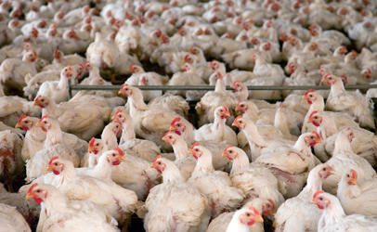Parts of industry go antibiotic-free
Early in the year, fast-food chain Chick-fil-aannounced its plans to phase out over the next five years serving chicken raised with antibiotics. Cargill later followed with an announcement that it would stop using antibiotics for growth promotion in raising its turkeys.
And Perdue and Tyson told consumers that they no longer use antibiotics in their chicken hatcheries. Perdue also stated that it has not used antibiotics for growth promotion since 2007 and doesn’t use any human antibiotics in any of their feed.
Related research
Some interesting antibiotics research that came to our attention this year found that: antibiotics could help spread Salmonella between animals, that fish could be another source of resistance, multiple instances of methicillin-resistant Staphylococcus aureus (MRSA) transmission from livestock to humans, and the first carbapenemase identified in a food source.
Other stories of interest:
- American Medical Association Seeks Ban on Antibiotic Use on Farms for Growth Promotion
- Industry Rep Questions the Resources Devoted to Antibiotic Resistance Research, Prevention
- FRONTLINE Documentary Explores Use of Antibiotics in Food Animals
- Reuters Analysis of Poultry ‘Feed Tickets’ Show Systematic Antibiotics Use
- CA Governor Vetoes State Senate’s Animal Antibiotics Bill
- Largest School Districts Going With Antibiotic-Free Chicken
© Food Safety News
More Headlines from Food Policy & Law »
Tags: agriculture appropriations, antibiotic resistance, antibiotics, Cargill, CDC, Chick-fil-A, chicken, Cory Booker, cromnibus, CSPI, Dianne Feinstein, Elizabeth Warren, FDA, Foster Farms, France, FSIS, Guidance 213, Keep Antibiotics Working, Kirsten Gillibrand, Louise Slaughter,Margaret Hamburg, NARMS, NRDC, Obama administration, PAMTA, PCAST, Perdue, Pew Charitable Trusts, Preservation of Antibiotics for Medical Treatment Act, Preventing Antibiotic Resistance Act, Rosa DeLauro, Salmonella, Supermoms against Superbugs, Sweden, The Netherlands, Tyson, UK, White House, WHO
http://www.foodsafetynews.com/2014/12/2014-in-review-animal-antibiotics/#.VnRSs71Z3wQ

