Support the Clean Water Act in Pennsylvania: Jeffrey Ripple
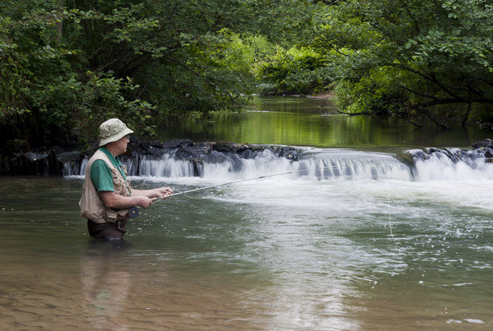
By PennLive Op-Ed
on June 13, 2014 at 2:00 PM, updated June 13, 2014 at 2:02 PM
By Jeffrey Ripple
Last month, the Army Corps of Engineers and Environmental Protection Agency proposed a rule to clarify which bodies of water are covered under the Clean Water Act.
As an avid trout angler, and the owner of a business that conducts land surveys, land development plans, and permitting plans, I see the importance of the Clean Water Act in my personal professional life.
Central to the proposed rule is the protections offered to intermittent and ephemeral streams, which may flow only part of the year. Despite their seasonal flows, they are incredibly important as spawning habitat and for rearing juvenile fish, such as Pennsylvania's native brook trout. In addition, whether these streams contain fish or not, they are the building blocks for larger downstream rivers. Historically, they were clearly protected by the Clean Water Act for three out of the four decades of its existence, but these protections were lost in a series of Supreme Court decisions.
The history of the Clean Water Act in Pennsylvania is certainly worth noting. In the 1970s, the idea that a river like Little Juanita would be fishable or swimmable was almost impossible to believe. Today it's a renowned trout stream thanks to the Clean Water Act. The same could be said of the Three Rivers outside of Pittsburgh which now regularly hosts a bass fishing tournament. The EPA and Corps' rule is not an "overreach" of the federal government, but a simple restoration to the way the Clean Water Act was implemented as cleaned up these streams. These waters that are important for anglers across the state were protected, they lost those protections, and now, through this proposal, they are regaining them. It's that simple.
My business regularly works with a variety of industries in permitting and development. I am not opposed to natural gas pipelines or hydraulic fracturing, I only wish for it to be done in a way that protects our best fisheries and ecosystems. Deciding which waters are or are not covered by the Clean Water Act not only protects good fish habitat, but offers better clarity to regulated industries.
Anglers such as me understand the challenges faced by industry, but we also intimately know how important it is to protect small streams. We worry that if developers do not follow the right rules when building infrastructure, they will leave behind a legacy like that of Pennsylvania's numerous abandoned mines, where the state and conservation groups are left to clean up a polluted mess. We're still recovering from the damage done by mines that are decades and even a century old. The Stonycreek River was named the "River of the Year" for Pennsylvania in 2012 despite being completely polluted by acid mine drainage in the early part of the last century. Today because of the Clean Water Act, much of the river supports healthy fish populations and even wild rainbow trout.
At the end of the day, we're not just looking out for our personal hobbies. There are 1.1 million anglers in Pennsylvania, and in 2011 they spent $485 million on equipment and trips. That doesn't count the license money that goes back to conservation, the taxes they pay, or the impact they have when dollars spent at gas stations, motels and outfitters trickle throughout the community. In addition to the economic benefit of hunting and fishing, protecting these waters matters for Pennsylvania's urban areas. The drinking water of more than 8 million people depends on intermittent, ephemeral, and headwater streams.
Whether you're fishing for brook trout in a small headwater stream, bass in the Allegheny, or just enjoy having clean water when you turn on your tap, you should thank the Clean Water Act, and you should support the EPA and Corps of Engineers as they try to make the law as strong for future generations as it has been for ours.
Jeffrey Ripple, environmental committee member, Pennsylvania Trout Unlimited resides and works in Berlin, PA as a professional land surveyor and fly fishing guide. He was born and raised in the Laurel Highlands.

